* Run the **Replication wizard** Tool

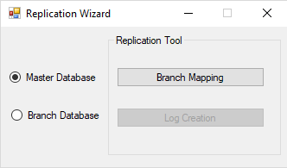

* Select Branch Mapping, window will be like :

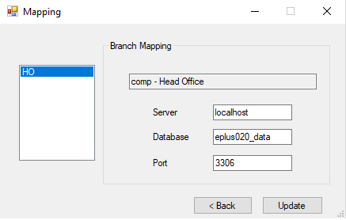

Enter the details of branch and click update.

* Then choose Log Creation

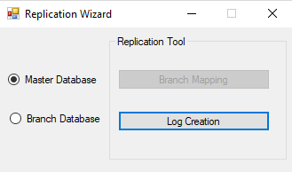

By choosing Log creation,window will be like:

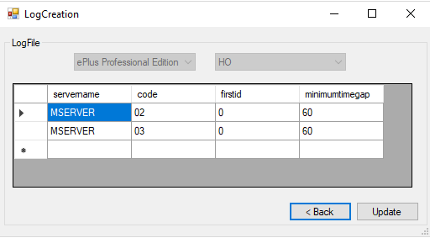

Edit the minimumtimegap and firstid if needed, and click update.

* Take the backup of the eplus professional edition.

Tools->Backup eplus->Backup->select the location and save

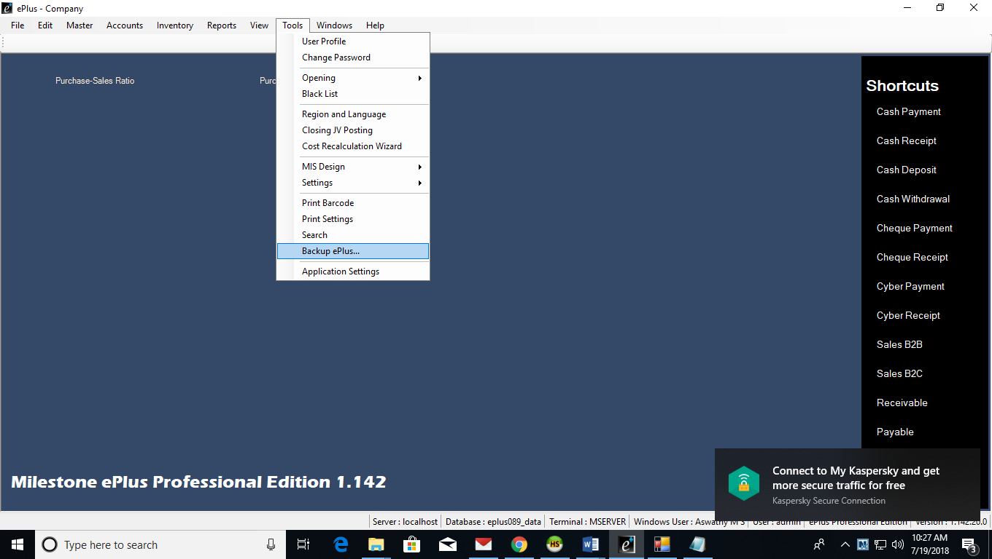

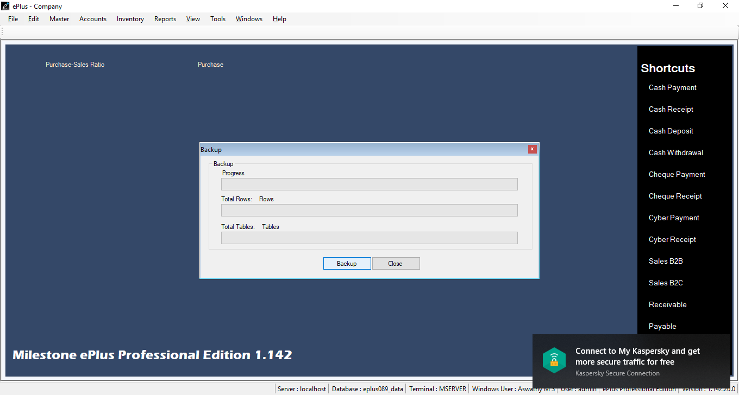

* Install this backup in eplus basic configuration wizard
* Before opening the software run the **ePlus Database distribution** application where you will have to set the branch code including the software and version details, Click update.

